Business Dress Options - Women’s Clothing
Buying your first suit or smart outfit can be daunting so here are some options. All of them are cheaper than the 6th form uniform we would have brought and can be used outside of school in a variety of smart contexts. Remember business smart is NOT wearing your old uniform. It is choosing something comfortable that you would wear in an aspirational workspace. If you are joining MAP then we expect you to take pride in the way you dress. We reserve the right to ask you to change into our school uniform or send you home if you don’t dress appropriately.
Any questions email us at: Map6th@marineacademy.org.uk

- Teachers have to wear smart clothing to work and I personally find it easiest to have a ‘work wardrobe’ that I keep separate from my home clothes.
- To keep things simple and to keep the cost down I have a pair of plain trousers, a skirt, a blazer and then a few different blouses that go with both so I can change my top each day.
- Your skirt is always shorter that you think it is! Black tights are also good to ensure that when you sit down the skirt is still appropriate.
- Sometimes it is better to spend slightly more and buy things that you know are going to last.
- To minimise hassle buy clothes that dry easily so you can wash overnight if you need to. Polyester or viscose are the best for this. In addition, polyester blouses don’t need ironing provided you hang them up.
- Always go for comfort! If you are in between sizes then get the bigger size and wear a belt or similar to help with the fit. Being uncomfortable will affect your learning.
- When buying a blouse make sure you can fit a top underneath it for when it is chilly and that is appropriate to wear without it in the summer (stand in the light and make sure it is not see through!). This way you can wear the same clothes all year round and always be comfortable. Remember, no blouses/tops should be low cut, be ‘strappy’ or show any part of your midriff.
- Shoes are a tricky one as cheaper ones don’t always last and can often not be very flexible and rub.
- Retailers that do half sizes can be helpful (eg. M and S). Remember, no heels for safety reasons.
- Don’t go and buy items of clothing if you are not sure to be told in September it is not acceptable we will ask you to put the old uniform back on.

Examples of Business Dress
Below are some examples of acceptable ‘business dress’ suggested by staff and past students.
Trousers
Retailer | Cost | Picture | Product Details
Marks and Spencer | £19.50 | 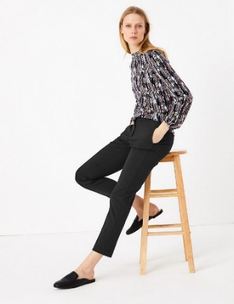 | M&S COLLECTION  Slim Leg Ankle Grazer Trousers  Product code: T595563
Next | £18.00 | 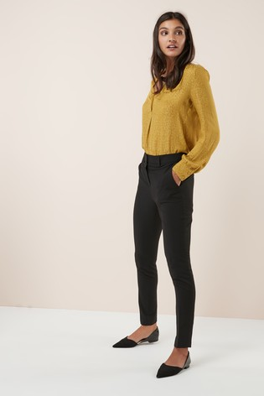 | Black Slim Trousers  Product code: S2654308_C101
Matalan | £14.00 |  | Slim Fit Trousers  Product code: S2654308_C101
TU at Sainsbury’s | £15.00 | 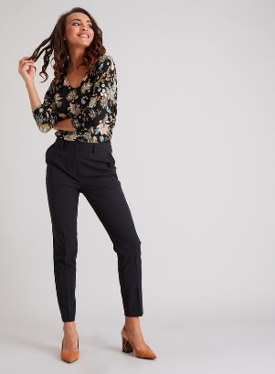 | Black Tapered Leg Trousers With Stretch  Product code  136251538

Skirts
Retailer | Cost | Picture | Product Details
Marks and Spencer | £19.50 | 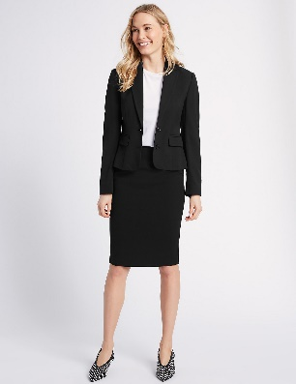 | M&S COLLECTION  Tailored Pencil Skirt (Blue/Black)  Product code: T591551S
Matalan | £10.00 |  | Pencil Skirt  Product IDS2629023_C101

Blouses
Retailer | Cost | Picture | Product Details
Matalan | £12.00 | 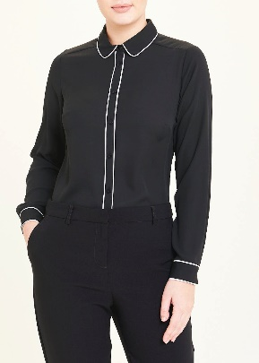 | Black Long Sleeve Piped Blouse  Product IDS2765037_C101
Matalan | £14.00 | 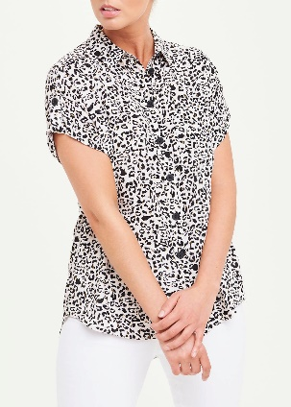 | Short Sleeve Animal Print Button Shirt  Product IDS2785926_C47Q
H and M | £17.99 | 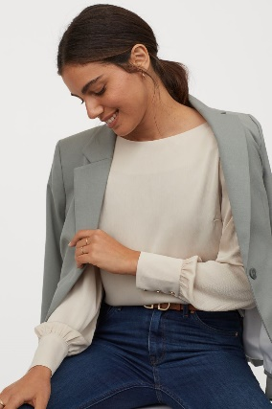 | Satin boat-necked blouse  Art. No.0863409002
George at Asda | £12.00 | 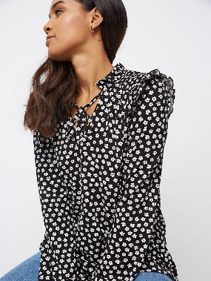 | Black Floral Print Top
Primark | £8.00 | 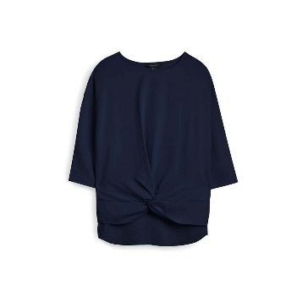 | Navy Twist Hem Blouse  Product code: 9190710
New Look | £15.99 | 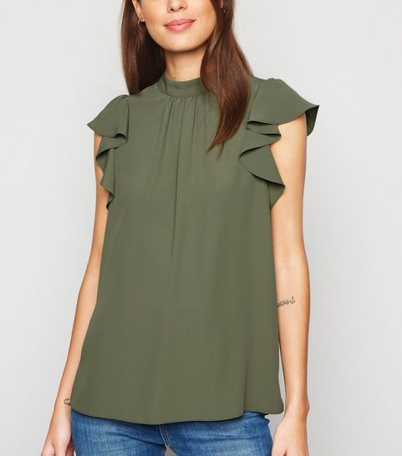 | Khaki High Neck Flutter Sleeve Blouse  Product Code: 660140234

Blazers
Retailer | Cost | Picture | Product Details
George at Asda | £18.00 | 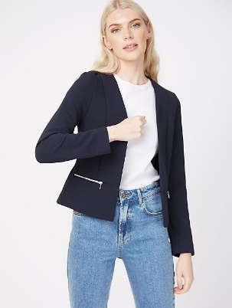 | Navy Zip Detail Blazer
New Look | £19.99 | 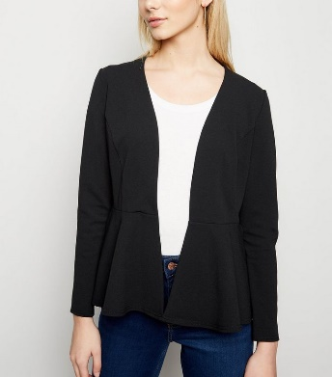 | Black Peplum Blazer  Product Code: 650042501

Shoes

Retailer | Cost | Picture | Product Details
Marks and Spencer | £15.60 | 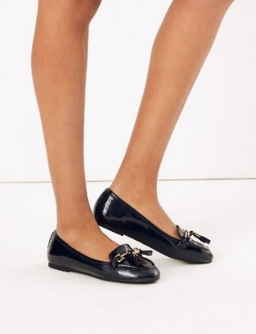 | Tassel Trim Loafers  Product code: T025415
New Look | £19.99 | 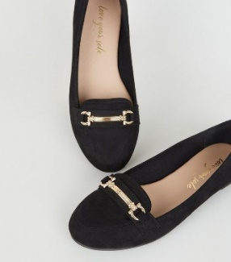 | Black Suedette Bar Front Loafers  Product Code: 620372801
Tu at Sainsbury’s | £12.00 | 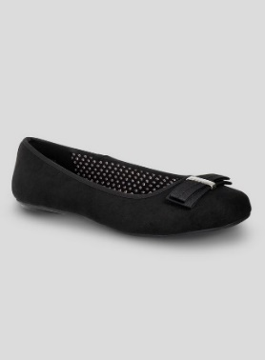 | Black Ballet Pump With Bow  Product code  136198870
Shoe zone | £14.99 | 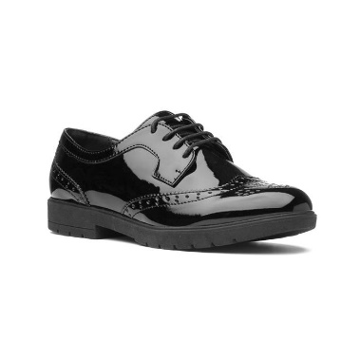 | Lilley Womens Black Glossy Lace Up Brogue Shoe  Style Code: 15000
Deichmann | £19.99 |  | Graceland  BLACK PATENT LOAFERS  Item No.: 1140367

Image | Info
Shirt/ Blouse  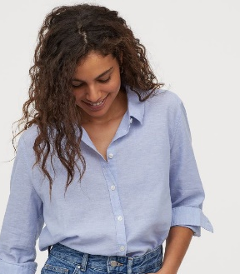 | Shop: H&M  Link: https://www2.hm.com/en_gb/productpage.0816938002.html  Price: £17.99
Jacket | Shop: Primark  Link: https://www.primark.com/en/the-edit/women/trailblazers/a/29449d49-17e2-4463-b628-8b1b44523ad4  Price:£15.00
Trousers | Shop: Next  Link: https://www.next.co.uk/style/st259470/516898#516898  Price: £18.00
Skirt | Shop: Asda  Link: https://direct.asda.com/george/women/skirts-shorts/black-denim-pencil-skirt/GEM755299,default,pd.html?cgid=D1M1G20C11  Price:£10
Shoes  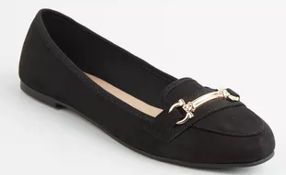 | Shop: NewLook  Link: https://www.newlook.com/uk/womens/footwear/flat-heels/c/uk-womens-footwear-flat-footwear#/?q=:relevance:colourGroupCode:1&page=0&sort=relevance&content=false  Price:£19.00

Student Recommendation
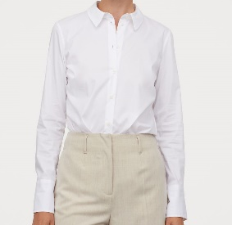 | Shop: H and M  Link: https://www2.hm.com/en_gb/productpage.0850917001.html  Price:12.99
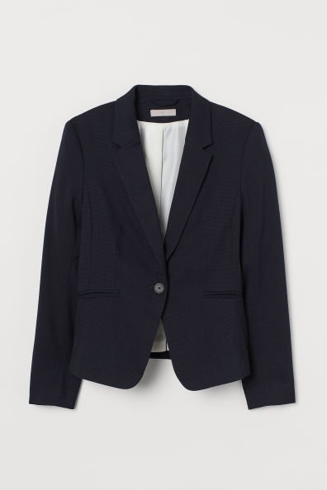 | H and M  Search: Fitted Jacket  Price: 24.99  https://www2.hm.com/en_gb/productpage.0568601007.html
H and M
https://www2.hm.com/en_gb/productpage.0568597007.html
Price: 19.99
H and M Pencil Skirt
Price: 17.99
https://www2.hm.com/en_gb/productpage.0783329001.html
Shoes | Shop: NewLook  Link: https://www.newlook.com/uk/womens/footwear/flat-heels/c/uk-womens-footwear-flat-footwear#/?q=:relevance:colourGroupCode:1&page=0&sort=relevance&content=false  Price:£19.00
Total outfit cost: With Skirt: £74.95 With Trousers: £76.95

