Boy’s Professional Dress
Buying your first suit or smart outfit can be daunting so here are some options. All of them are cheaper than the 6th form uniform we would have brought and can be used outside of school in a variety of smart contexts. Remember business smart is NOT wearing your old uniform It is choosing something comfortable that you would wear in an aspirational workspace. If you are joining MAP then we expect you to take pride in the way you dress. We reserve the right to ask you to change into our school uniform if you don’t dress appropriately.
Any questions email us at: Map6th@marineacademy.org.uk
Item of Clothing | Info
Mr Cole’s Suggestion
Shop: ASOS – Light blue shirt
Link: https://www.asos.com/new-look/new-look-poplin-shirt-in-regular-fit-in-light-blue/prd/11451571?colourwayid=16356715&SearchQuery=&cid=3602
Price: £12.99
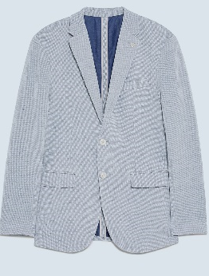 | Shop: Zara – Grey Blazer  Link: https://www.zara.com/uk/en/textured-blazer-p01608410.html?v1=39101766&v2=1567546  Price: £29.99
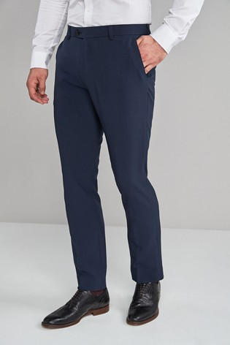 | Shop: Next – Navy trousers  Link: https://www.next.co.uk/g242282s23#331909  Price: £18.00
Shop: Next – Black Derby Leather Brogues
Link: https://www.next.co.uk/style/st456754/411526#411526
Price: £32.00
Total Cost | 2 shirts 2 trousers 1 blazer 1 shoes = £123.97  ✓ Cheaper than standard £130-200 uniform
My top 3 tips when buying clothes for work:
- If you can, opt for leather shoes as they will wear better and last longer.
- Try on trousers before you buy to make sure they are a comfortable fit.
- For versatility, buy shirts with collars that work with or without a tie.

Item of Clothing | Info
Mr White’s Suggestion
Shop: H and M (Cotton Shirt)
Link: https://www2.hm.com/en_gb/productpage.0821173001.html
Price: 24.99 (2pack)
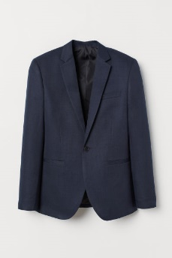 | Shop: H and M  Link: https://www2.hm.com/en_gb/productpage.0742191001.html  Price: 34.99
Shop: H and M
Link: https://www2.hm.com/en_gb/productpage.0739239010.html
Price: 17.99
Shop: H and M
Link: https://www2.hm.com/en_gb/productpage.0834333004.html
Price: 24.99
Cost | 2 shirts 2 trousers 1 blazer 1 shoes = £119.96  ✓ Cheaper than standard £130-200 uniform
My top 3 tips when buying clothes for work:
- Always get a blazer – looks so much smarter and you can get away with not ironing your shirts.
- Don’t get a shirt that’s too small and sit around all day barely fitting in it – be comfortable.
- Try shoes on before you buy – I have had these before though and they are comfortable.

Item of Clothing | Info
Mr Bass’ Suggestion
Shirt  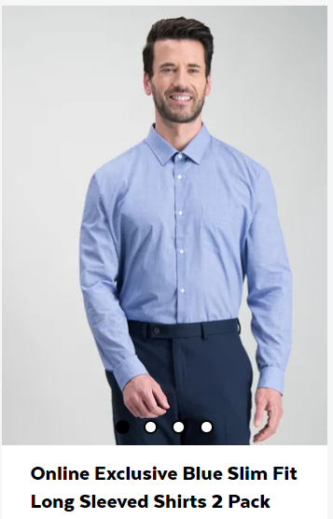 | Shop: Sainsbury’s  Link: https://tuclothing.sainsburys.co.uk/c/men/men-formal-shirts?q=%3AnewArrivals%3AsleeveLength%3ALong+Sleeve%3Astyle%3ASlim+Fit&text=#  Price: £17.00 (2 pack)
Blazer  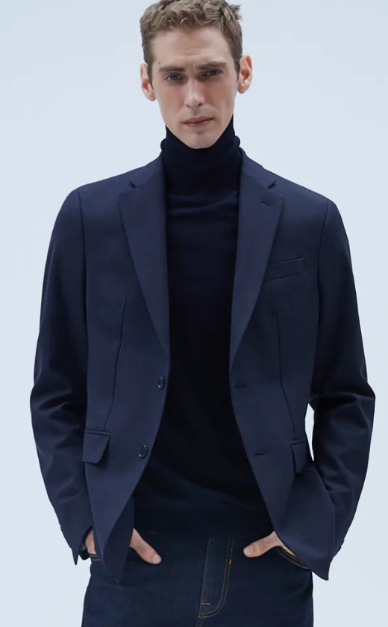 | Shop: Zara  Link: https://www.zara.com/uk/en/comfort-textured-suit-blazer-p04284735.html?v1=42106391&v2=1591697  Price: £19.99
Trousers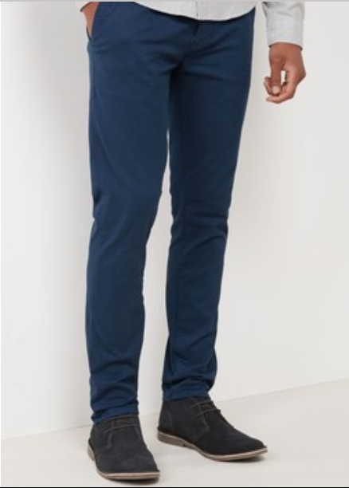 | Shop: Next  Link: https://www.next.co.uk/g242414s6/356415#356415  Price: £22
Shoes  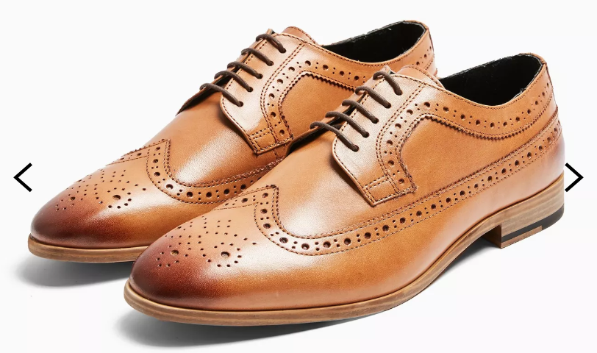 | Shop: Topman  Link: https://www.topman.com/en/tmuk/product/shoes-and-accessories-1928527/view-all-shoes-boots-5172700/tan-real-leather-collins-brogues-9581904  Price: £49.00
Total Cost | 2 shirts 2 trousers 1 blazer 1 shoes = £107.99  ✓ Cheaper than standard £130-200 uniform
My top 3 tips when buying clothes for work:
- Always try shoes on before you buy.
- Check you collar size for shirts.
- Make sure you are comfortable….avoid skinny fit unless you want to sweat all day!

Item of Clothing | Info
Mr Davies’ Suggestion
Shirt | Shop: Debenhams  Link:https://www.debenhams.com/webapp/wcs/stores/servlet/prod_10701_10001_080010500180_-1  Price: £30 for a pack of 3
Suit | Shop: Burton  Link: https://www.burton.co.uk/en/bruk/product/suits-281561/mens-suits-view-all-1880789/2-piece-blue-texture-slim-fit-suit-9748105  Price: £69 for a full suit!!  Remember to check sizing. – suits look amazing but always try them on.
Shoes | Shop: ASOS  Link: https://www.asos.com/asos-design/asos-design-brogue-shoes-in-tan-faux-leather/prd/11086383?colourwayid=16373028&SearchQuery=&cid=27116  Price: £17.50
Total Cost | 3 Shirts, 1 suit, 1 pair of shoes: £116.50  ✓ Cheaper than standard £130-200 uniform
My top 3 tips when buying clothes for work:
- Buy white shirts. They look smart and they will go with every blazer or trouser combination.
- Do not buy skinny fit! It’s really uncomfortable for work. Go with slim fit as this looks smart and is comfortable to wear.
- Look out for end of season sales. You can get some great bargains on decent clothes. Burton and ASOS are my ‘go to’ brands.

