



SEND Information Report 2026-2027


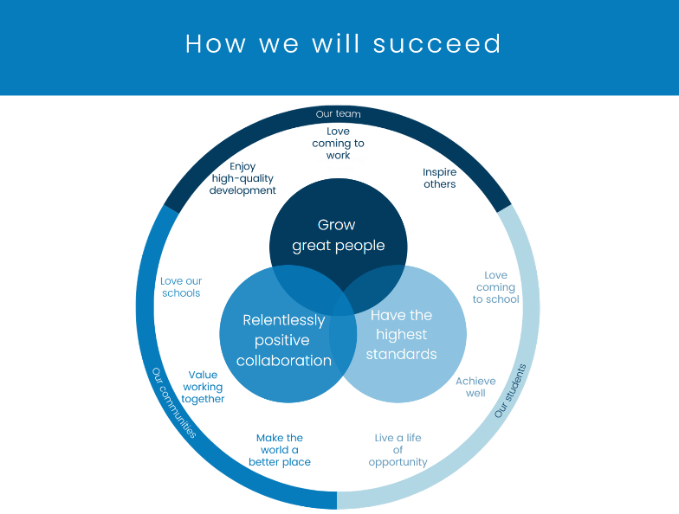
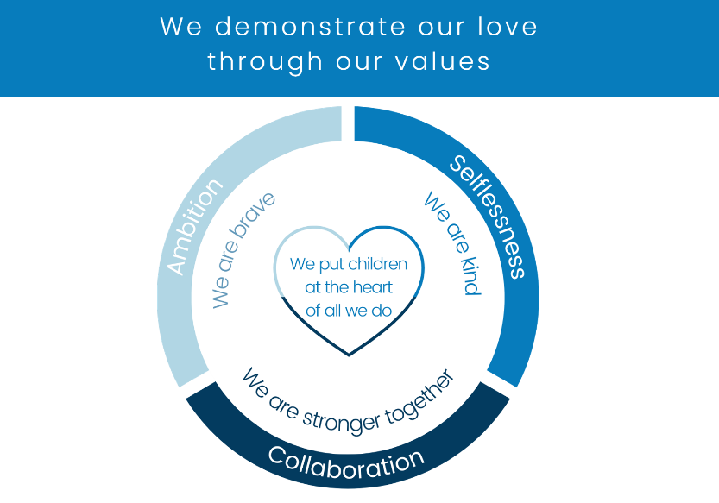

Statement of Intent

At Marine Academy Primary, we believe all children deserve the very best possible start and we aim to enrich the lives of all our pupils.
Marine Academy Primary is dedicated to providing the best education for all, and the brightest future. Our mission “To provide an outstanding education that ensures all pupils reach their greatest potential and live by life’s highest values.” is at the heart of everything we do. This is from an inspirational curriculum which gives children experiences on which to base their learning and their future life choices, to a strategic staffing, recruitment and CPD plan which ensures that all teachers and staff members can improve, not because they are not good enough but because they can be even better (Dylan William).
All children with Special Educational Needs and Disabilities (SEND) are welcome at Marine Academy Primary. Full support will be provided to each child who has SEND requirements with well thought out strategies to overcome any barriers to achievement. Marine Academy Primary is a fully inclusive school providing an outstanding and caring education so all pupils can achieve their potential. The Academy has won a range of Inclusion and SEN Awards, including the Education Business Award for Inclusive Education 2015, highly accredited for Education Business Award for Inclusive Education 2016, GHP Social Care Award for Special Educational Needs Coordinator South West 2017, GHP Social Care Award for Excellence in Academic Special Educational Needs Management South West England in 2018 and 2019, winner of the SEN Inclusion Award at the Education Business Awards 2019, the Nasen Primary Provision award 2019, the Bronze Mental Health Charter Award 2025 and the Inclusion Quality Mark 2026.
Parents/Carers and pupils are fully involved and the progress of children with SEND is monitored towards meeting specifically identified goals and targets.
The Inclusion Team invite Parents/Carers to a monthly Conversation Café, which takes place the first Monday of every month. Members of the Inclusion Team are on hand to offer advice, give recommendations and answer any questions that Parents/Carers may have regarding the Special Educational Needs or wellbeing of their child.
The Academy uses specialist strategies, which include a strong commitment towards training and developing all teachers and Teaching Assistants in their understanding of SEN to ensure that everyone is a ‘teacher of SEN’. Our approach reflects the Education Endowment Foundation's model of Inclusive Teaching. We recognise that inclusive practice begins with strong universal classroom teaching for every pupil. Where this is not sufficient on its own, carefully planned adaptations and additional support are provided to enable pupils with SEND to access ambitious learning alongside their peers. These approaches work together to promote participation, independence and success for all learners.
Excellent care, guidance and support contributes significantly to pupils’ personal development to make them all feel safe and secure and make the best possible academic and personal progress.
Our school will:
- Have a designated SENCo who is part of the Senior Leadership team and who has completed the National Award for SEN Coordination.
- Have a named Link Governor for SEN.
- Have a SEN Information Report, Inclusion Strategy and SEN policy. These will be available on the website and reviewed yearly by senior leaders and Governors.
- Ensure pupils wit SEN have full access to extra-curricular opportunities and ensure they are represented in every aspect of school life.
- Ensure every aspect of the school’s KPI’s have a reporting mechanism for SEN.
- Ensure leaders are committed to their role in the local area partnership’s strategy to improve the
experiences of, and outcomes for, pupils with SEND.
In addition, we will use the following guiding principles as part of our work in supporting children with SEN:
- First, all staff are aware of the SEN students they teach, tutor or mentor: we consciously build strong relationships with these students, gaining knowledge of their subject strengths and areas for development, their individual contexts and aspirations.
- We focus relentlessly on developing them as individuals: their talents, their academic endeavours and acknowledge and address the unique barriers they face.
- At the front of our minds we remember that we are powerful advocates: we have a responsibility to ensure that every student with SEN is prioritised for enriching academic and extra- curricular opportunities that challenge and inspire them.
- We develop SEN students as leaders in our community: we believe in them; we prioritise them at every opportunity, proactively encourage them to take on leadership roles and ensure they develop the skills in order for them to be successful.
- We know that excellent teaching is at the heart of success: supported by our ambitious learning culture, our pedagogy, knowledge-rich, cohesive curriculum, consistent routines, feedback, high expectations and strong knowledge of individuals can and do make a difference to our most vulnerable students.
- We know that excellent teaching is adaptive and meets the needs of the learner: teachers engage with incremental coaching and evidence-informed approaches to refine, develop and improve in order to ensure our learners achieve their potential. We understand the importance of subject mastery and seek always to develop subject knowledge and expertise.
- We address financial and practical barriers to learning and enrichment: we provide essential equipment where necessary for SEN pupils.
- We offer opportunities for independent practice: we explicitly teach students learning habits, which are embedded in lessons and monitor their success throughout their school career and intervene, where necessary, to support progress.
- We raise aspirations and focus on the future: we provide guidance and support that allow our students to explore opportunities they may not have considered. Students are prioritised for careers advice and work experience. We develop strong links with universities and businesses in order to encourage all students to broaden their horizons.
- We understand that excellent attendance is fundamental to student success: we intervene early and positively when students are absent and ensure that any barriers to excellent attendance are addressed.

Contact Details
Special Educational Needs Coordinator (SENC0) | Isabel Critchlow  primary@marineacademy.org.uk  01752 213939
Staff member with overall responsibility for pupils with Medical Needs | Julianne Brenton  primary@marineacademy.org.uk  01752 213939
SEN Governor | Alasdair Williams
Where is the Local Authority’s Local Offer published? | https://www.plymouthonlinedirectory.com/plymouthlocaloffer
Contact details for support services for parents of pupils with Special Educational Needs. | Plymouth Information Advice and Support for SEND (PIAS)  https://www.plymouthias.org.uk/  01752 258933  pias@plymouth.gov.uk

Implementation
Questions | School Response
What kinds of special educational needs are provided for at Marine Academy Primary? | Marine Academy Primary is a mainstream, inclusive school for children aged 2-11 that fully complies with the requirements set out in the Special Educational Needs Code of Practice (2014). A pupil has SEND where their learning difficulty or disability calls for special educational provision, namely provision different from or additional to that normally available to pupils of the same age. (SEND Code of Practice, 2015, p.94) There are four broad areas of need for children with SEND. Trained and experienced staff are able to support learners who may have difficulties with:  - Cognition and Learning  - Speech, Language and Communication needs  - Social, Emotional and Mental Health  - Sensory and/or Physical Difficulties  - Children on the Autistic Spectrum  We make reasonable adjustments to our practices so as to comply with the Equality Act (2010). Children with SEN, either with or without an Education and Health Care Plan, are welcome to apply for a place in school in line with the school admissions policy. If a place is available, we will use our best endeavours, in partnership with parents, to make the provision appropriate and accessible to meet the SEN of pupils at this school. For children with an EHCP, parents have the right to request a particular school and the local authority must comply with that preference and name the school or college in the EHC plan unless:  - it would be unsuitable for the age, ability, aptitude or SEN of the child or young person,  - Or the attendance of the child or young person there would be incompatible with the efficient education of others, or the efficient use of resources.  Before making the decision to name our school in a child’s EHCP, the local authority will send the governing body a copy of the EHCP and then consider their comments very carefully before a final decision on placement is made. In addition, the local authority must also seek the agreement of the named school.
What are the policies for identifying children with SEND and assessing their needs? | We have highly trained teachers and teaching assistants who can identify and help support children who are experiencing any difficulties and the SENCO coordinate  this work across the whole Academy. All children are different so every child is unique with their learning journey. Class teachers continually track the progress of all children in their class. They have daily discussions with classroom support staff to ensure every child is meeting their potential as well as monitoring written work and regularly observing children during their learning. Class teachers and teaching assistants can discuss any concerns they have as and when needed with the SENCO, and all teachers have termly Pupil Progress meetings and Inclusion Reviews.  There are many ways that we may identify a SEND for example:  - Liaising with all Nursery providers and other primary schools to ensure that information on children transitioning into the Academy is shared effectively.  - Teachers and Nursery Practitioners carry out regular assessments, so that they are able to quickly identify any child who is experiencing particular difficulties.  - Parents may raise concerns about their child.  - Other professionals working with a child outside of the Academy may raise concerns or highlight a specific need.  - Pupils views  - Review attendance and exclusion data for students with SEND
How does Marine Academy Primary evaluate the effectiveness of the provision for children with SEND? | Subject leaders and the SENCo measure the effectiveness of provisions made for pupils as part of their subject monitoring cycle. This will include learning walks, book looks and pupil conferencing.  The effectiveness of interventions are measured on a Provision Map which shows the  pre-assessment data, expected outcomes, post data and evaluations. Interventions will be monitored by the Classroom teacher and SENCo and where necessary, appropriate additional training will be provided to staff running interventions.  Alongside evaluating interventions, leaders monitor the quality and impact of adaptive classroom practice through lesson visits, book scrutiny, pupil voice and professional dialogue with teachers. This ensures adaptations continue to support high expectations and successful participation. Leaders regularly review inclusive teaching through professional development, coaching, lesson visits and ongoing evaluation. Staff work collaboratively to refine classroom practice using current educational research so that inclusive teaching continues to improve over time.  If a child is supported through the ‘Team Around Me’ process or an ‘Early Help  Assessment’, the multi-agency team working with the child will meet every 6 weeks to review progress against outcomes.  Pupils with an EHCP will have an annual review where the progress towards outcomes and the appropriateness of provisions in Section E and F of the EHCP will be reviewed.  Mrs Critchlow reports regularly to the Governing Body. We have a Governor who is  responsible for SEND, who attends meetings where possible, and whom reports to the  Governing Body.
What are the arrangements for assessing and reviewing children’s progress towards outcomes? | As an Academy, we track and analyse children’s progress in learning against age related expectations on a termly basis. The class teacher continually assesses children and notes areas where they are improving and where further support is needed.  Pupil Progress meetings are held each term with the class teacher and a member of the Senior Leadership Team. In these meetings, children who are not making at least expected progress are highlighted and a plan is created.  Where specific needs are apparent, the Academy has a range of assessments which can be used to explore a child’s strengths and difficulties in more detail. The Plymouth Graduated Approach to Inclusion framework is used as an electronic tool to support teachers and school leaders to identify, assess and record and review the needs of children and young people requiring additional or special educational provision. There are four broad stages of support, all which are implemented using an Assess, Plan, Do, Review cycle. The primary aim of this framework, is to ensure that levels of support at an early stage, which are part of a school’s universal offer, are implemented before a pupil progresses through to targeted, targeted plus or specialist levels of support.  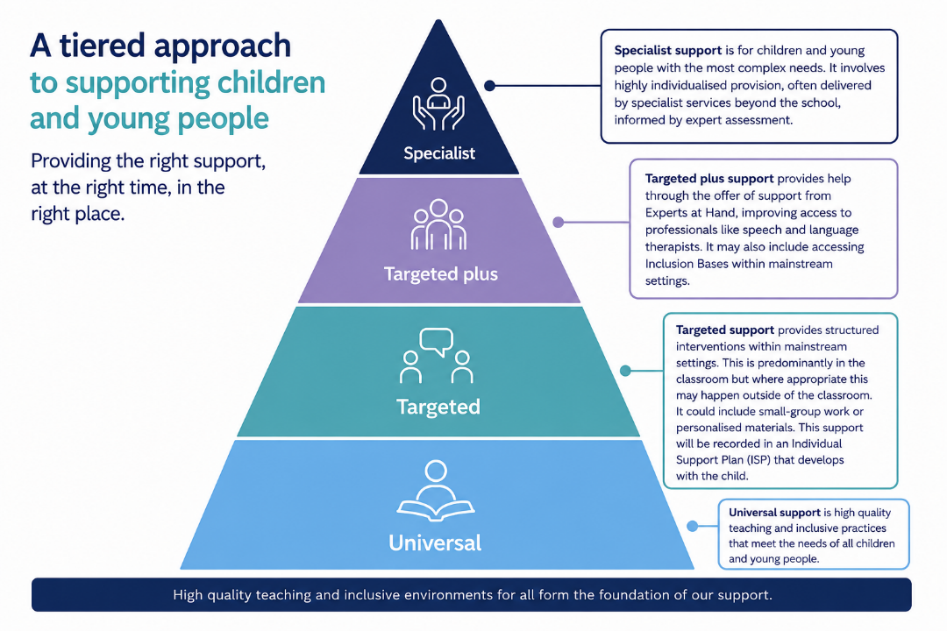  For a very small percentage of pupils, whose needs are significant and complex and the SEN Support required to meet their needs cannot reasonably be provided from within the school’s own resources, a request will be made to the local authority to conduct an assessment of education, health and care needs. This may result in an Education, Health and Care (EHC) plan being provided.
What is our approach to teaching children with SEND and adaptations are made to the curriculum and the learning environment for children with SEND? | We have a highly ambitious and broad curriculum and we expect our SEND pupils to be fully involved in all lessons and extra-curricular activities. All Students, including those with special educational needs, are taught the school’s broad and balanced curriculum which can be found here.  We passionately believe that all teachers are the teachers of children with SEND. High Quality Teaching is a non-negotiable for every child in our Academy. Our highly skilled teachers will use evidence-informed approaches including explicit instruction, carefully sequenced learning, modelling, regular checking for understanding, retrieval practice, effective feedback and scaffolding that is gradually removed as pupils become more independent. These approaches benefit every learner but are especially important for pupils with SEND.  There is an expectation that teachers will be highly aware of the learning needs of all children and will ensure that the learning is coherently sequenced to SEND pupils needs, starting points and aspirations. All curriculum areas include retrieval practice and lessons are planned with cognitive overload in mind. Learning links build upon previous lessons and years and these links are made explicit to the children. Lessons are planned with scaffolds and we build in additional time for guided student practice to ensure there is a high success rate. We have minimised the amount of interventions and when they happen. The best teaching takes place in class and we do not want children missing out on any part of the curriculum as this could be a barrier to them achieving an aspiration for the future.  What would high quality targeted classroom teaching look like for my child?  - The teacher would have the highest possible expectations for your child and all pupils in the class  - That all teaching is built on what your child already knows, can do and can understand  - Different ways of teaching are in place to ensure that your child is fully involved in all aspects of the lesson.  - Specific strategies (that may be suggested by the SENCo or professionals) are in place to support your child to learn.  - Your child’s class teacher will have carefully checked on your child’s progress and will have decided that your child has a gap/gaps in their knowledge and need some extra support to make the best possible progress  We carefully plan support so that pupils become increasingly independent learners. Adults provide the right level of support at the right time, gradually reducing prompts and scaffolds as pupils develop confidence, resilience and independence.  The school recognises the importance of the findings by the Education Endowment Fund’s summary of recommendations for SEN in mainstream schools and any in class support by teaching assistants, adheres to their recommendations on effective deployment of teaching assistants. Teaching assistants complement, rather than replace, high-quality teaching. They are deployed strategically to reinforce learning, promote independence and provide carefully planned support that enables pupils to participate fully within the classroom.  Pupils with medical needs will be provided with a detailed Individual Health and Care Plan, compiled in partnership with specialist nurses and parents and if appropriate, the pupil themselves.  We are fully committed to ensuring that the Academy is accessible to all children and will  always be happy to discuss individual requirements where necessary. The Academy has a  number of ways in which it is accessible to all:  - Designated disabled parking space in the main car park  - Accessible toilet facilities by the main reception area and at the lower end of the  - Academy near the Key Stage One classes and in the Nursery.  - A lift situated on the lower level to provide access to the upper level.  - The Academy grounds and outdoor learning are accessible for all children.  Please see our Accessibility Policy for further details.
What additional support for learning is available to pupils with special educational needs? | When a child has been identified with special educational needs, the class teacher  will ensure that the child can access the curriculum appropriately and this will be  discussed with the parents formally at Parents/Carers’ meetings.  The SENCo will liaise with external professionals where appropriate and will work with staff to ensure that every child is able to access the curriculum.  If appropriate, specialist equipment may be given to the child e.g. writing slopes,  pen/pencils grips or easy to use scissors.
How are children with SEND enabled to engage in activities available with children in the school who do not have SEND? | All staff are committed to promoting the involvement of all children in all aspects of the curriculum including activities outside the classroom. Where there are concerns of safety and access, further thought and consideration is put in place to ensure needs are met for all children. Where applicable parents are consulted and involved in planning for inclusion. A full risk assessment is always carried out prior to planned school trips to prioritise inclusion and safety for all children. Where needed, additional adults may be deployed to support with trips. We also encourage children with SEND to access our lunchtime and after school clubs and will put in additional adult support if needed.  We believe that successful inclusion means every pupil feels that they belong within our school community. We actively promote participation in classroom discussion, enrichment opportunities, leadership roles, educational visits and wider school life. We regularly seek pupil voice to ensure children feel valued, listened to and included.
What support does the school provide for improving emotional and social development? | All our staff know and care about all the children and their needs. Time within the curriculum is dedicated to fostering self-esteem and confidence. Our carefully planned induction process ensures that through meetings with feeder pre-school settings and conversations with parents, we can anticipate the medical, social and emotional needs of all children.  The Academy offers a variety of pastoral support for children who may be encountering emotional difficulties, starting with the support offered to children in class. This is achieved through a comprehensive curriculum for children’s spiritual, moral, social and cultural development.  We use a Trauma Informed approach to support children’s emotional needs. We have two TISUK trained practitioners working in our school. Our Positive Behaviour Management Policy, which includes guidance on expectations, rewards and sanctions is followed consistently by all staff. We view behaviour as a form of communication. For children who may have complex social and emotional needs, a Protect, Relate, Regulate and Reflect support plan may be put in place in agreement with parents and professionals.  The school is a very calm environment because of the clear routines and structures in place across the school.  As a mentally healthy school, we adopt a whole-school approach to mental health and wellbeing. Our vision is that every child is taught the skills they need to be emotionally literate, self-aware and mentally well. We can increase and blend support to ensure every child has the social and emotional skills to achieve their potential. We have a three tier approach to supporting pupils with their mental health.  At the core of tier 1, is the importance of giving children an emotional vocabulary, the time and space to listen and reflect on how they feel and a set of tools to help them move to a more positive set of feelings when sadness, frustration, anger, loneliness, grief are experienced. Our vision, is that most children thrive with our ‘tier 1’ provision. As part of this provision, every child will benefit from weekly whole class teaching on emotional literacy and well-being. Further information on this can be found in our Curriculum policy here (add link).  Sometimes children need a more bespoke approach if their needs are acuter. At tier 2, we offer pupil group and individual support through short term interventions such as . . .  If we feel that a child’s needs require specialist support and advice, we will work with you as a family and we may decide together to refer to external professionals such as CAMHs or the Mental Health in Schools Team.
What expertise and training do staff have to support children with SEND and how is specialist expertise secured? | We have a culture of sharing good practice and expertise which enables us to ensure that staff, have the skills needed to effectively support children with SEND. All the teaching staff are kept up to date with changes in SEND legislation and practice both nationally and locally. Our regular in-house CPD (Continual professional development) programme offers training around key aspects of SEND.  We regularly audit and review staff training needs and provide relevant training to develop whole school staff understanding of SEND and strategies to support inclusive and high-quality teaching. The school uses its best endeavours to secure the special educational provision called for by any students’ needs. We also provide staff with information about effective strategies to use within their class and adhere to the principle that ‘All teachers are teachers of children with special educational needs’ to ensure that all teachers and staff are equipped to deal with a diverse range of needs.  We work closely with external agencies to support staff training and development of expertise. We aim to ensure we have a variety of skills among the staff. Mrs Critchlow holds the National SENCo Qualification and a diploma in Trauma Informed Schools UK. All Academy staff receive training when required.  The SENCO attends termly SENCO updates to keep abreast of current legislation and practices. The school employs a Speech therapist as well as an Inclusion teacher who is in school two days a week supporting individuals and groups of children who struggle with anxiety, managing their emotions and attitudes to learning. We also have our very own trained Therapy Dog (Little Bear) who helps regulate our pupils.  There may be times when children require additional support from outside agencies and Experts at Hand to receive more specialised expertise; the agencies used by the Academy are:  - The Communication and Interaction Team (CIT/CITEY)  - NHS Speech and Language Therapists (SaLT)  - The Educational Psychology Service  - School Nursing Service  - Child Development Centre  - Multi-Agency Support Team (MAST)  - Child and Adolescent Mental Health Service (CAMHS)  - Educational Welfare Officer  - Barnardo’s  - Social Care  - Learning Mentor  - Art Therapist  - Outdoor Learning Therapist  - Plymouth Information Advise and Support Service (PIAS)  - Outreach Teams from Specialist Provisions  - Health Visitor  - Portage  - ATAN (Advisory Teacher for Additional Needs)
How do we secure the equipment and facilities needed to support pupils with SEND? | The SENCo oversees the SEND budget and commissions services, such as our speech therapist and Inclusion teacher to meet the needs of current and future cohorts. As needs of students and cohorts are identified or change specific equipment and facilities are bought using the SEND Top up funding as agreed by the SENCo, for example buying Reader pens to support identified students.  We work closely with Occupational Therapists and acting on advice from them, a number of pupils have access to learning aids such as writing slopes, ergonomic pens, wedge cushions or pencil grips. Other pupils have been enabled through the use of tablets or Dictaphones to record their learning.  Our schools are wheelchair accessible from certain points (an old building which has been adapted) and we have disabled toilet facilities and a wet-room shower facility. We have an accessibility plan which is reviewed regularly.  If appropriate we would access further support and advice from outside agencies through the TAM process and access additional funding from the Local Authority if a child’s needs exceed the funding available in our delegated budget.
How do we consult with the parents of children with SEND and involve them in their child’s education? | From the very beginning of any child’s educational journey with us, we work hard to engage parents and build positive home-school relationships. We know that parents know their children best and it is important that we, as professionals, listen and understand when parents express concerns about their child’s development. Daily opportunities for contact are provided at the end of the school day. If a longer conversation is felt necessary then a time can be made with the class teacher. Arrangements can be made to speak in more detail to the class teacher or SENCo at any time by appointment or by emailing the year group account.  Our universal offer also includes the progress of all children being reported to parents verbally three times per year and in writing through Annual Reports at the end of every academic year. These reports also include information about any intervention support the child is receiving.  Parents of children with special educational needs are at the heart of the decision-making process with regards to the provision for that child. Provisions are reviewed regularly with the parents. The TAM (Team Around Me) process allows for a close working relationship between the school and parents.  Children and parents of children who have Education and Health Care Plans  (EHCPs) will be invited to meet the SENCo to review progress. The views of the child and the parents/carers will form a key part of these discussions.  We aim to ensure that the children are aware of the interventions that they are involved in, what the learning goals are, when they will take place and how well they are doing.
How do we consult with children with SEND and involve them in their education? | We use a child-centred approach where the views of the child are sought in ways appropriate to their age. Class teachers, teaching assistants and school leaders are always available to listen to children’s opinions, questions and points of view. The SENDco spends time with individuals to gain their thoughts as part of the annual review and the TAM processes.  Children are helped to complete an ‘All about Me’ page that explains how they feel the adults working with them can best support them. Personalised targets are set, agreed and reviewed with children and their parents/carers.
What are the school’s arrangements for handling complaints from parents of children with SEN about provision? | If a parent of a child with special educational needs has a concern regarding their child’s provision, they would be encouraged in the first instance to speak to the class teacher. The class teacher can then involve the SENCo where necessary. A parent is also free to contact the SENCo directly. It is hoped that all concerns or questions can be resolved through open working relationships and open lines of communication.  Mrs Critchlow is the Special Educational Needs Coordinator (SENCo). If you have any concerns regarding your child’s learning, she can be contacted directly via the Academy email address, primary@maineacademy.org.uk or an appointment can be made to see her through our admin team. If you would like to make a complaint, then please follow the Academy’s Complaints Policy.
How do we involve outside agencies in meeting children’s SEND and supporting their families? | We have established relationships with outside agencies including the Educational Psychology Services, health and speech and language specialists. We draw on their professional knowledge to support individual children as well as to provide staff training. Outside agencies contribute to staff’s professional development by delivering training on specific programmes of intervention, for example Precision Teaching, or strategies for supporting children with identified difficulties.  Professionals from outside the school may be invited to attend meetings to discuss individual situations where it is felt that support above and beyond what the school is able to offer is necessary. In these cases parents/carers will be consulted and consent sought so that the agencies are able to work in supporting the overall development of the child.
How will children be supported when moving to a new class or when joining or leaving the Academy? | A number of strategies are in place to enable effective pupil’s transition. These include:  On entry:-  - A planned programme of visits for pupils starting Nursery. Additional visits are arranged if needed Parent/carers are usually invited to a meeting at the school and are provided with a range of information to support them in enabling their child to settle into the school routine  - The SENCO meets with all new parents of pupils who are known to have SEND to allow concerns to be raised and solutions to any perceived challenges to be located prior to entry.  - If pupils are transferring from another school, the previous school records will be requested immediately.  - Enhanced transition meetings may take place if the child has additional support from the Early Years Inclusion Service.  Transition to the next class/Key stage  - The current teacher completes a transition meeting with the new class teacher.  - Historically, a transition morning is arranged to give pupils a chance to experience their new class before the new academic year starts. We know that early identification of possible problems is more beneficial to both the child and the teacher and these need to be addressed as early as possible.  - New class teachers will be invited to TAM, Annual Reviews and EHAT meetings in the Summer term with the permission of pupils and parents.  - Bespoke transition plans will be put into place if required. This may be additional visits to the classroom when no one is in there, spending time playing games with the new class teacher or a transition booklet.  Transition to a new school in Year 6  - Transition days are generally arranged for pupils with SEN depending on need.  - The annual review in Y5 for pupils with an Education, Health and Care plan begins the process where parents are supported in making decisions regarding secondary school choice.  - Parents will be encouraged to consider options for the next phase of education and the school will involve outside agencies where appropriate, to ensure information received is informative, with questions being answered.  - Accompanied visits to other providers may be arranged as appropriate, depending on the secondary school’s COVID 19 risk assessment.
Where can I find out more information regarding on the services available for children with  special educational needs or disabilities? | The Plymouth Online Directory (POD) contains a directory of services available. The link below will take you to the POD and provides information on how the Local Authority expects schools to meet the needs of children with SEND and their families; this is called ‘The Local Offer’ and can be found by visiting this website: https://www.plymouthonlinedirectory.com  A glossary of SEND terms is included in the appendices of the SEND Code of Practice; - https://assets.publishing.service.gov.uk/government/uploads/system/uploads/attachment_ data/file/398815/SEND_Code_of_Practice_January_2015.pdf
Who are the best people to talk to in our school about my child’s difficulties with learning, special educational needs or disabilities? | The Class Teacher is responsible for:  - Checking on the progress of your child and identifying, planning and delivering any additional help your child may need and letting the SENCo know as necessary.  - Writing Academy Based Support Plans, based on the smaller steps of progress needed for success and sharing and reviewing these with parents at least once a term.  - Personalised high quality teaching of your child  - Ensuring that the School’s Information report and policy is followed in their classroom for all pupils with SEN  The SENCo is responsible for:  - Developing and reviewing the Schools SEN Information Report and Policy  - Co-ordinating all of the support for pupils with SEN  - Ensuring that you are:  - Involved in supporting your child’s learning  - Kept informed about the support your child is receiving  - Involved in reviewing how your child is doing]  - liaising with all other professionals who may be coming in to school to support your child  - Updating the schools SEN Register and making sure that the records of your child’s progress are kept up to date  - Providing or sourcing specialist support for staff in the school, so they can help children with SEND in the school to achieve the best possible progress.  The Headteacher is responsible for:  - The day to day management of all aspects of the school; this includes the support for pupils wit SEND.  - The Headteacher will make sure that the governing body are kept up to date about issues relating to SEN.  The SEND Governor is responsible for:  - Making sure the necessary support is given for any child with SEND that attends the school.

Impact
What has gone well this year?
- All SEN pupils are accessing our broad and ambitious curriculum which is captured through learning walks and pupil voice which demonstrate that children and young people feel supported and happy in their setting.
- Children identified as SEN Support have been supported and offered external support where appropriate.
- The Speech and Language Therapy team screened the entire Reception cohort and delivered a range of interventions to reduce the impact of speech, language and communication needs on learning and attainment.
- Marine Academy Primary achieved the Highest Award of the Inclusion Quality Mark.
- Marine Academy Primary have hosted several Attendance and Behaviour Hub events for schools and professionals from around the UK.
- We have developed strong links with the other schools within our Trust which has enabled us to share good practice across the schools and develop our own offer of support for pupils with SEN.
- Our SENCO has attended a number of training opportunities to further develop her knowledge and understanding of research and interventions related to SEND.
- We have developed stronger links with two of our closest secondary schools to ensure a quality transition for all pupils and have used the Transition Portal to alert those pupils who may be vulnerable or need an enhanced transition early to secondary schools.
- Staff have accessed a range of professional development this year which has continued to build on their knowledge of SEND and Trauma and how to implement support in the classroom.
- Our Mental Health and Wellbeing Practitioners have supported 40 pupils in 1:1 ELSA interventions this year.
- 35 children have accessed the Mental Health in Schools Team Workshops.
- 4 children have accessed a weekly Barnardos Intervention.
- 8 children have accessed a six-week online speech and language therapy intervention.
- We have been working closely with our Education Welfare Officer to ensure all children continue to strive for at least 96% attendance.

